Contents

General usage 1

The “screen” checkbox 2

The “snap” checkbox 3

WinCC Timer User Manual

Version: 210112

Author: MURA02

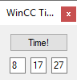

Minimized UI

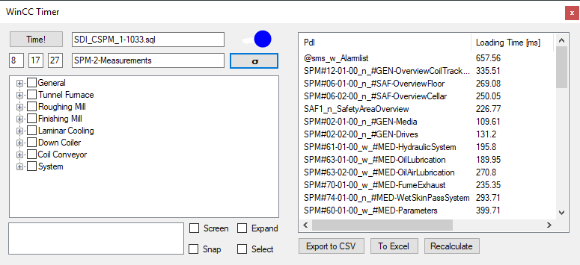

The WinCC Timer with expanded calculations

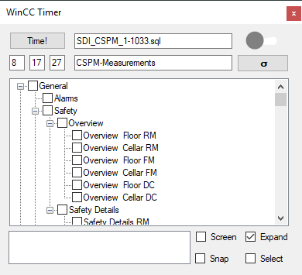

3 UI sans calculations

# Prerequisites

Requirements: The SQL file of the menu kept in the same folder.

# General usage

This program’s purpose is to quantify the loading time of WinCC pages.

The remote desktop session to the machine has to be visible (not minimized in the taskbar but also not necessarily maximized).

In order to do this it will require gathering several (I recommend around 10) datasets by the program itself (this process starts on pressing the “Time!” button).



Initial configuration of gathering runs

The above figure shows the configuration of a data gathering run that will run for 8 hours during which 17 full datasets are gathered for a project taking around 27 minutes to analyze.

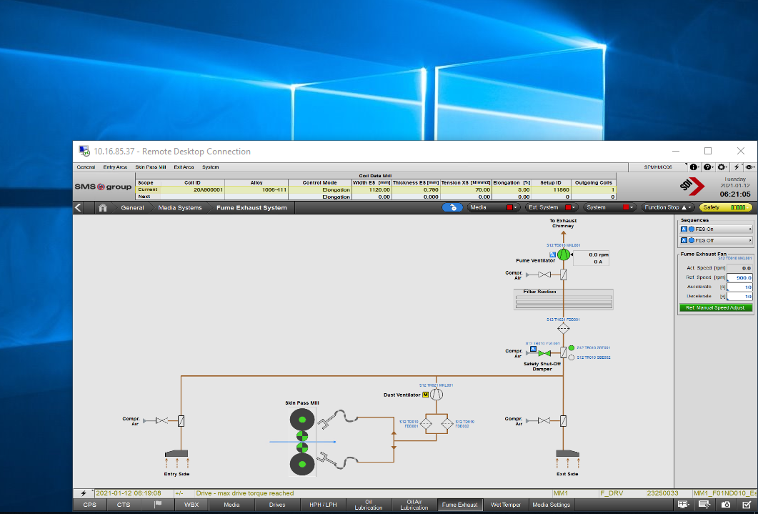

Possible desktop configuration for an RDP session for data gathering

A tested rule of thumb in order to estimate the time required to run a data gathering session is around 7 seconds per page (a 50-page project will take around 5.5 minutes).

Once the datasets are gathered, the sigma button calculates the average loading times for each individual page collected in the datasets – as shown in the picture, a data table appears on the right side once calculation is finished.

Once calculation is finished, press “Export to CSV” as desired to generate a csv file with the visible data.

Every notable UI object has a tooltip to explain its purpose or its connected action.

# The “screen” checkbox

Once checked, will take screenshots for every page in the calculations folder.

# The “snap” checkbox

If this checkbox is checked, the program will take a screenshot after 1.5 seconds after opening the pages, and only once. All .png files will be stored in the “Screenshots” folder.